UCONN VSTLF Installation Instructions
- Installation
  - Install java virtual machine. Get java from http://www.java.com/en/download/index.jsp
  - Extract VSTLF.zip file into a directory. (In fig.1 ‘H:\VSTLF)
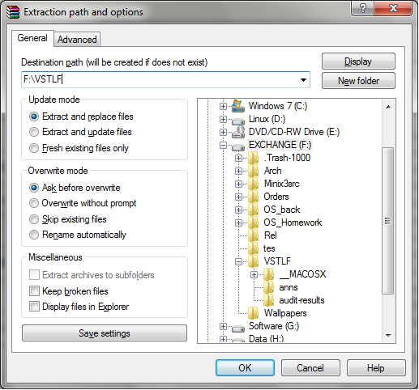
Fig 1. Extract VSTLF.zip
  - In this folder there is a java archive file ‘uconn-vstlf.jar’ and a directory ‘anns’. ‘uconn-vstlf.jar’ is the executable file. The directory ‘anns’ contains 12 neural network banks, each of which is used to forecast loads for five minute intervals in an hour.
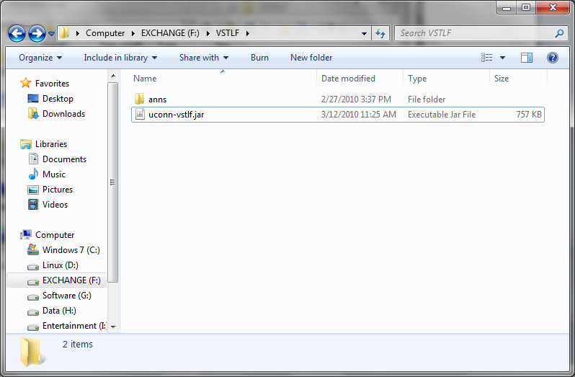
Fig 2. The VSTLF directory
- Training
To train the neural networks, run the following command:
java –Xmx300m -jar uconn-vstlf.jar train <lowBank> <highBank> <xmlFile>
<lowBank>, <highBack> are the number of the ANN bank in [0,11]. <xmlFile> contains the 5minute load data for training. The parameter “–Xmx300m” sets the heap size of Java Virtual Machine to be 300m, which is necessary for training from large set of data.
An example is shown is the following figure:
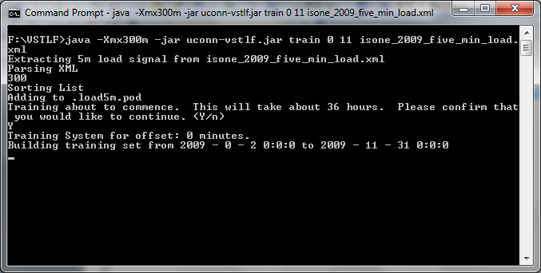
Fig 3. Training ANN banks
It trains ANN0~ANN11 using 5 minute loads in isone_2009_five_min_load.xml. Since training 12 ANN banks took almost 36 hours, it is advised to train these ANN banks on several computers. For example, train ANN0~5 on one computer and the rest on another.
When training completes 12 files named “bank0.ann”, “bank1.ann”… are generated. Put these files in the directory ‘anns’. As shown in figure 4:
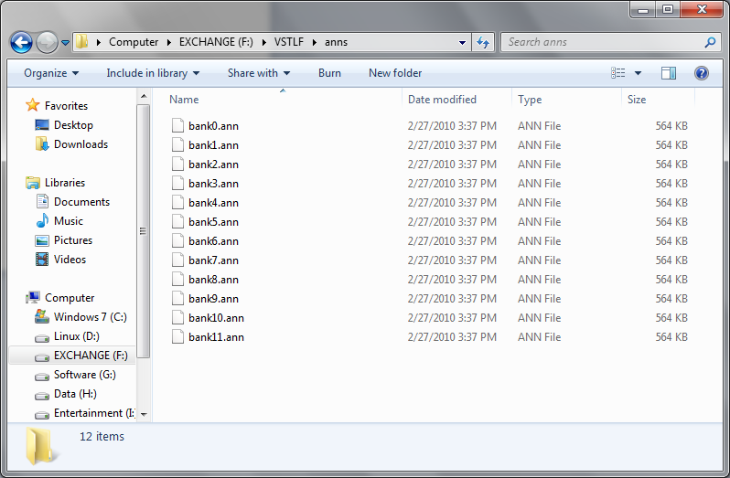
Fig 4. Ann bank directory
- Run the VSTLF GUI
The main entry point of the VSTLF system is the GUI (Graphic User Interface). To run the vstlf system, enter the following command:
java -jar uconn-vstlf.jar run-gui <currentDataFile> <24hrDataFile>
<currentDataFile> is a xml file containing 4 second loads. <24hrDataFile> is an xml file containing the 5 minute loads in the last 24 hours (It is used only for starting the vstlf system). These files are provided by ISO.
To run the gui, follow the steps below
  - Reset the vstlf system by running the following command.
java -jar uconn-vstlf.jar reset
It is necessary since the vstlf system will remember the state of the last run.
  - Setup the parser to parse the data in real time database into <currentDataFile>.
  - Prepare the file <24hrDataFile> containing 5 minute loads in the last 24 hours.
  - Make sure the 12 trained ANN bank files are in ‘anns’ directory.
  - Run the command:
java -jar uconn-vstlf.jar run-gui <currentDataFile> <24hrDataFile>
The GUI will start up and output the forecast information.
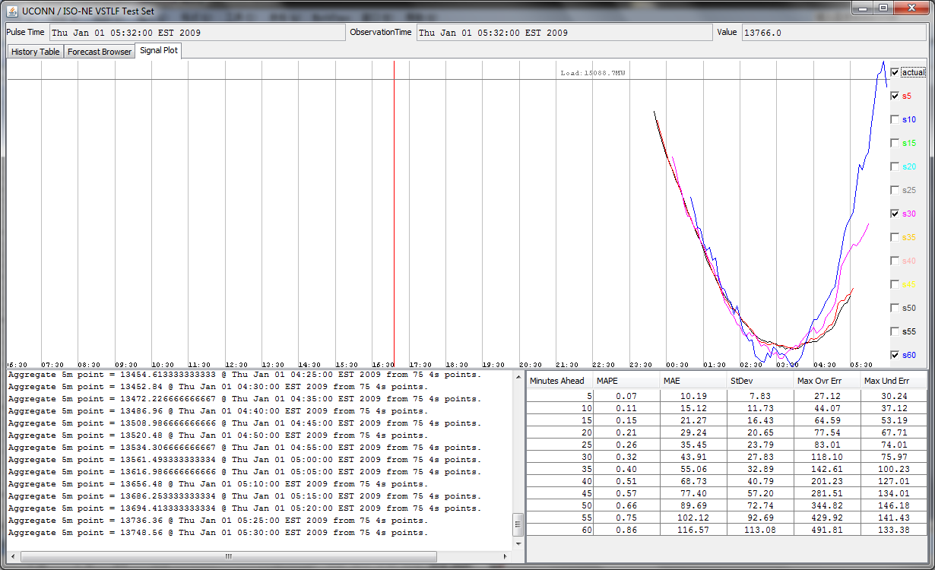
Fig 5. VSTLF GUI
- Test
To forecast loads starting from a historical point, enter the following command:
java -jar uconn-vstlf.jar run-gui <currentDataFile> <24hrDataFile>
"<testDate yyyy/MM/dd - HH:mm:ss>" <clockInterval>
The command line is similar to the one in section 3. It has two extra parameters. "<testDate yyyy/MM/dd - HH:mm:ss>" is the historical point you want to start from. <clockInterval> is the speed (measured in milliseconds) the loads are fed. (It can be much smaller than 4s to speed up the test). <currentDataFile> is an xml file (or Perst database) containing 4 second loads. <24hrDataFile> is an xml file (or Perst database) containing the 5 minute loads in the last 24 hours (from the historical point).
As an example, the following command starts VSTLF from 2009/01/01 by reading historical data form Perst databases (‘4s_Jun2008-9.pod’ and ‘5m_2007-Mar2009.pod’). A 4 second historical load is fed every 20 milliseconds.
java -jar uconn-vstlf.jar run-gui 4s_Jun2008-9.pod 5m_2007-Mar2009.pod "2009/01/01 - 00:00:00" 20
a GUI displaying the test will show up (as in Fig 6).

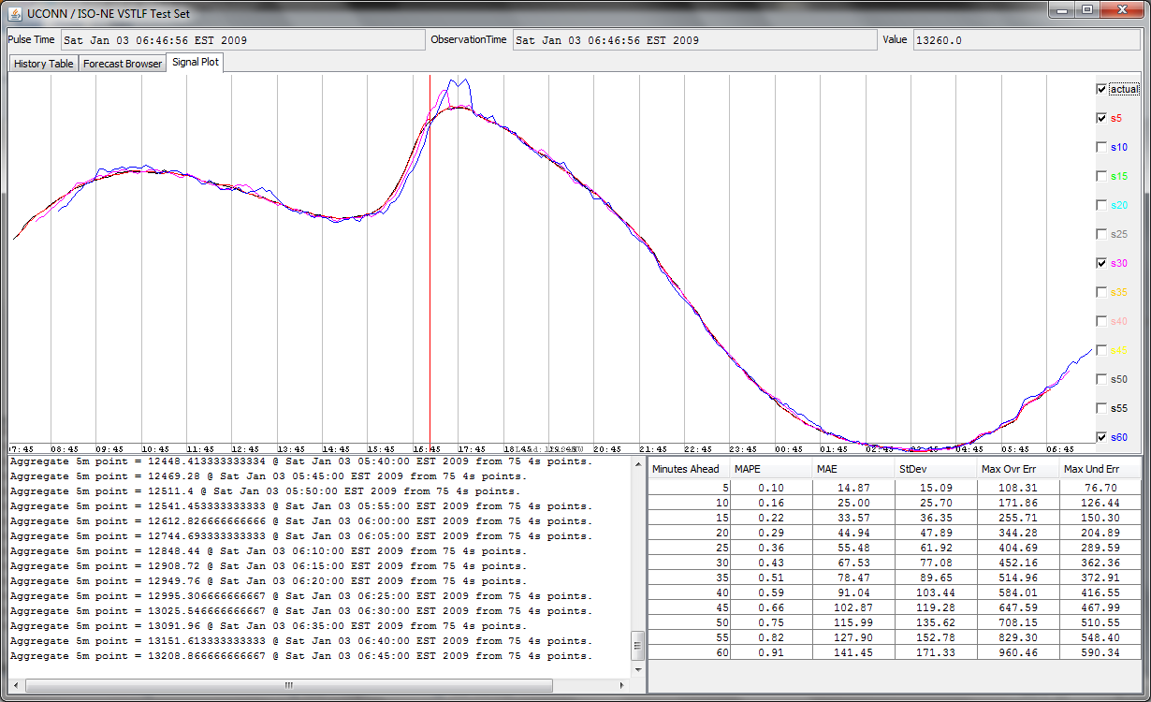
Fig 6. VSTLF GUI (Running in test mod)
- VSTLF GUI
The GUI of VSTLF displays the following information:
5.1 The historical load from the source file. As in fig 7:
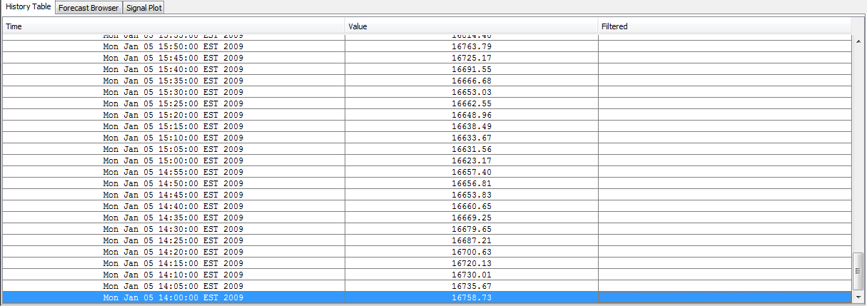
Fig 7. Historical Loads GUI
5.2 The forecast done every five minute, as in fig 8. The right side shows the actual loads and comparison with the forecast loads.
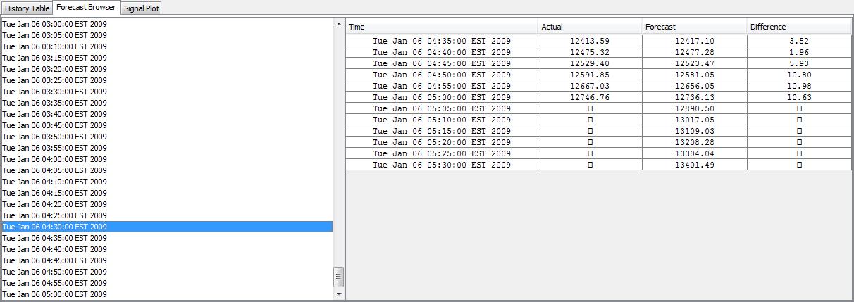
Fig 8. Forecast GUI
5.3 The plot of the forecast.
a) Click checkboxes on the right side to select the plot of actual load or forecast loads in next 5 minutes, 10 minutes, 15 minutes and so on (up to 60 minutes).
b) The grey vertical lines represent the five minute intervals. The red line represents the sunset time.
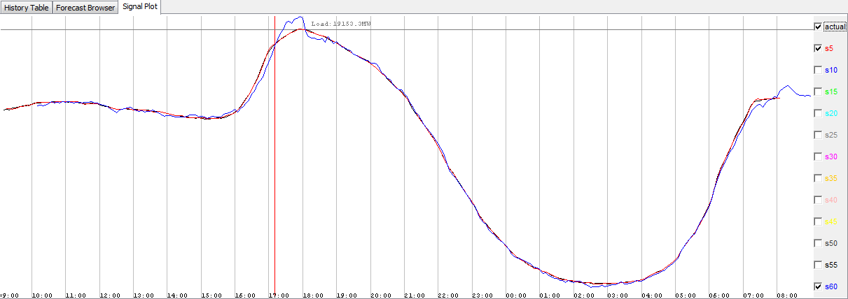
Fig 9. Plot of the forecast
5.4 Messages issued during forecast. As in Fig 10:
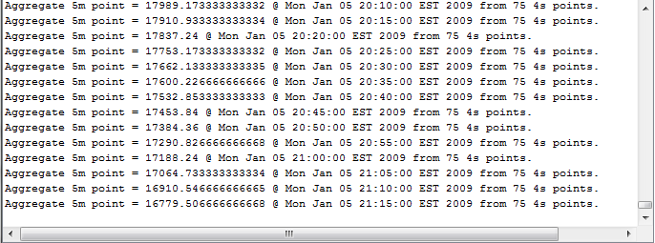 Fig 10. Messages
5.5 Statistics of the forecast. As in fig 11:
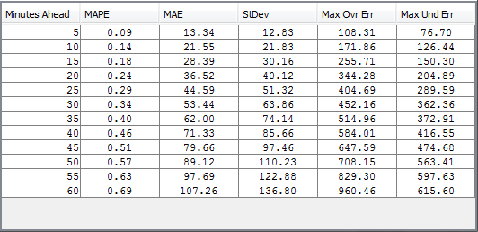
Fig 11. Statistic of ANN banks

